Experiment #7

DC Power Supplies

EENG 275 - W01

Prepared for: M. Fakoor, Professor

New York Institute of Technology

Prepared by: V. Cavalcante, Student

Partnered with: B. Saks, Student

Partnered with: Z. Zhou, Student

New York Institute of Technology

November 8th, 2019

**Experiment Objectives**

* Measure and Analyze a half-wave rectifier circuit
* Measure and Analyze a full-wave rectifier circuit
* Observe the operation of a 3-terminal regulator

**Equipment Used**

1- NYIT supplied Lab Kit

1- Digital Multi-meter (DMM)

1- DC Power Supply

1- Function Generator

1- Oscilloscope

1- Center Tapped Transformer

1- 10 Ω Resistor

1- 51 Ω Resistor

1- 100 Ω Resistor

1- 1 kΩ Resistor 1- 2.2 kΩ Resistor

1- 10 kΩ Resistor

1- 7805 Voltage Regulator

1- 100 uF Capacitor 1- 220 uF Capacitor

4- 1N4001 Diode

**Results**

**Circuit 7.1 Measurements:**

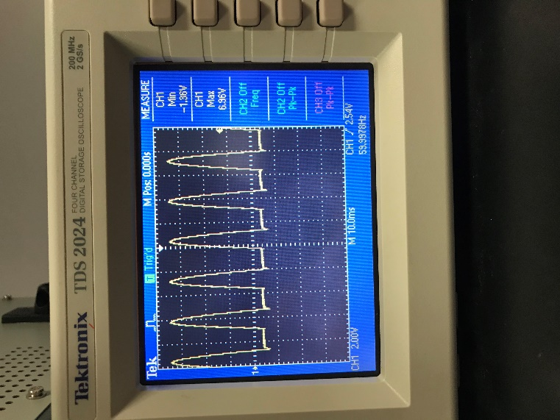 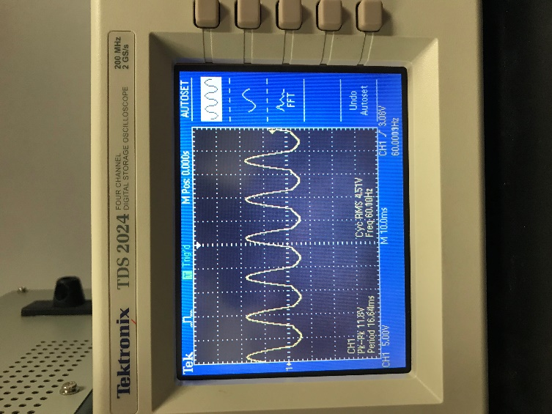

**Vin Vout**

**Circuit 7.2 Measurements:**

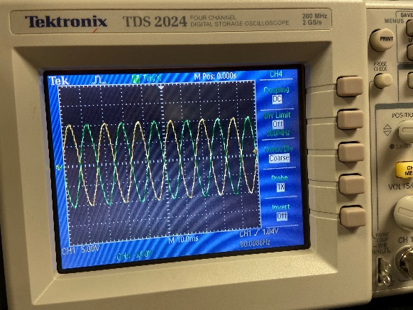

**Section 2 Negative (Green) and Section 1 Positive (Yellow)**

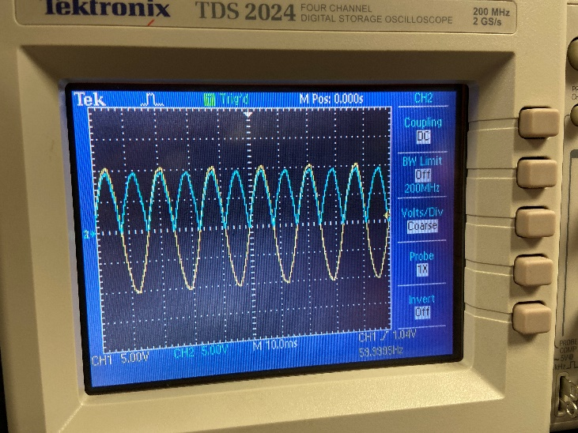

**Section 1 Positive (Yellow) and Vout (Blue)**

**Circuit 7.3 Measurements:**

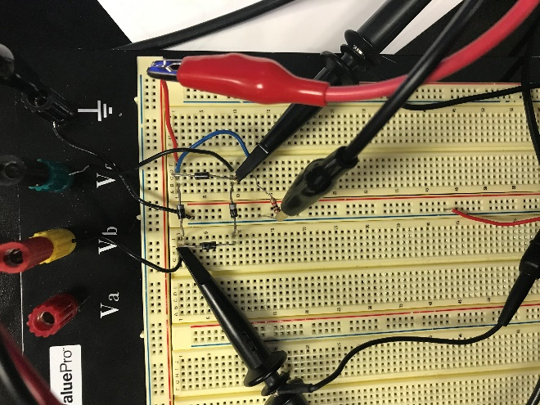

**Circuit for 7.3**

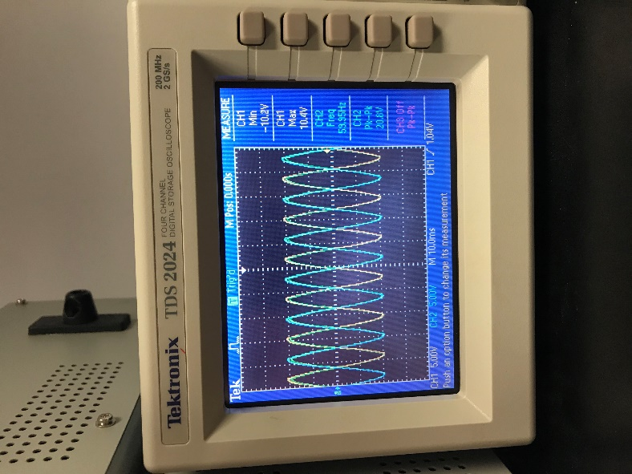

**Section 1 Positive (Yellow) and Vout (Blue) and Section 2 Negative (Green)**

**Circuit 7.4 Measurements:**

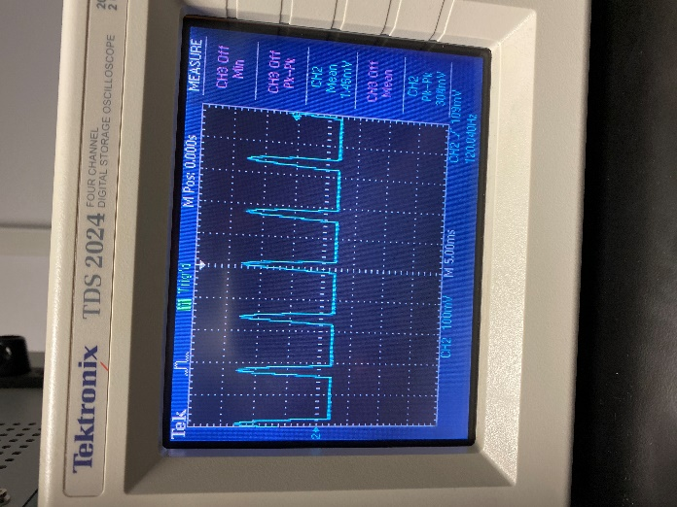 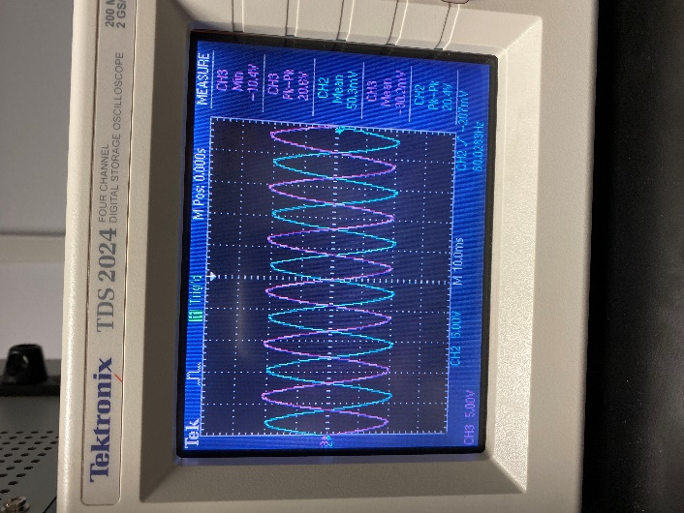

**Measurement for Vout Measurement for Section 1 and 2**

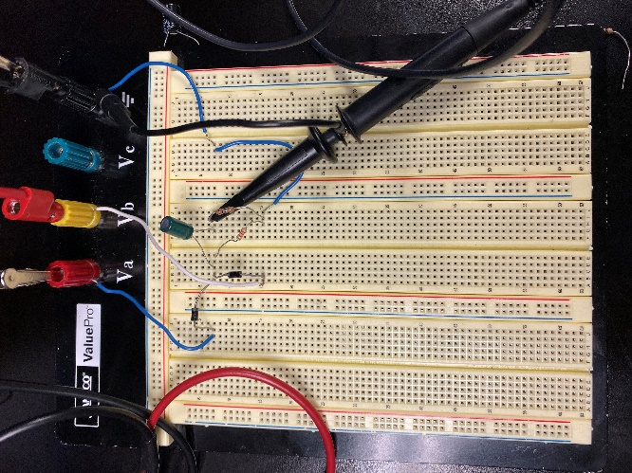

**Circuit for 7.4**

**Circuit 7.5 Measurements:**

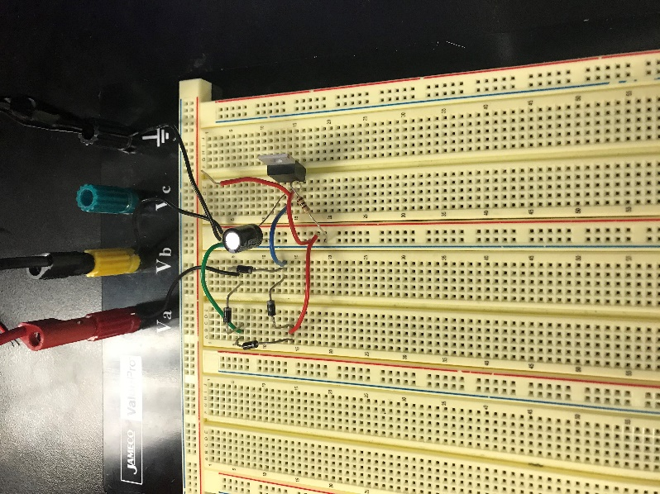 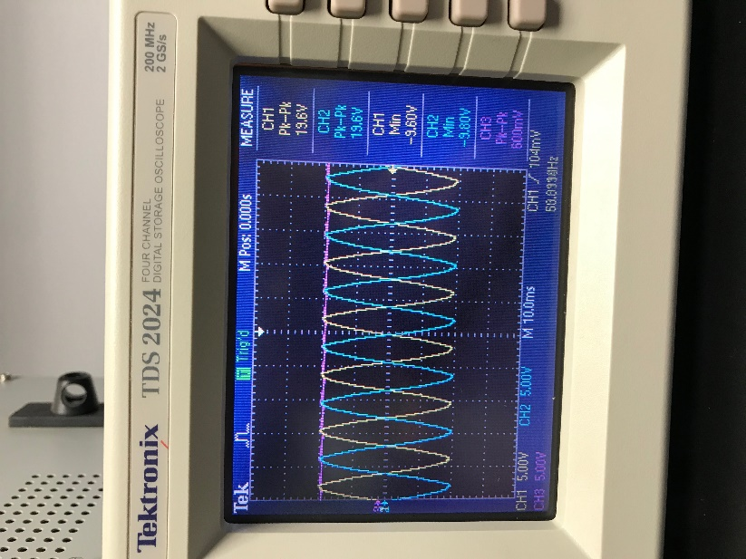

**Circuit 7.5 Circuit Measurements for 7.5**

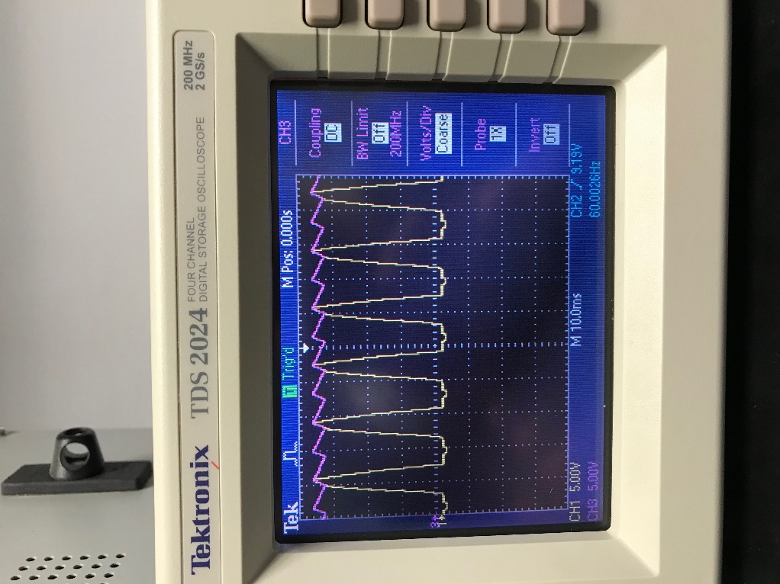

**With the Ripple Effect Increased**

**Conclusion**

* There is always a possibility of the breadboard to short-circuit and have one of the diodes to smoke out
* If the load resistor is too high there is a chance that it will damage the previous components down the line
* With the heat sink in a regulator the voltage output will always be the same as specified